*Assigned: 8-28-24*

*Due Date: 9-13-24*

CS 6210: Introduction to Scientific Computing

*Assignment 1*

*Artem Koval*

1. Below are the results of using the Vandermonde matrix to calculate an interpolating polynomial to exp(x) with evenlyand Chebyshev spacedpoints, as well as the associated errors:

**Figure 1** Interpolation using Vandermonde (Evenly-Spaced) Graphs and Errors

**Figure 2** Interpolation using Vandermonde (Chebyshev-Spaced) Graphs and Errors

In the case of interpolating the function y=ex on the interval [0,2], both algorithms tend to get more accurate as the value of n (the number of points initially selected for interpolation) gets larger. This trend stops at about n=21, where both algorithms reach peak accuracy, and increasing n at this point causes both algorithms to perform worse.

When comparing the use of evenly- or Chebyshev-spaced points, Chebyshev-spaced points turned out to be much more accurate at both high and low values of n, with the minimum error reaching 1.78e-15 (inf norm) and 3.01e-15 (2nd norm) at n=21.

1. Below are the results of using the bary and baryweights routines that use Lagrange polynomial interpolation:

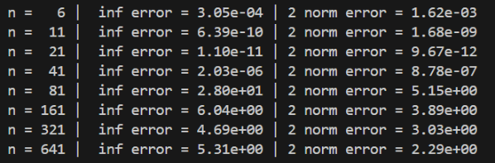

**Figure 3** Barycentric Lagrange Interpolation (Evenly-Spaced) Graphs and Errors

**Figure 4** Barycentric Lagrange Interpolation (Chebyshev-Spaced) Graphs and Errors

The Barycentric algorithm that uses evenly-spaced points (Figure 3) performed poorly at n>21, where significant errors begin to appear towards the edges of the graph. This issue gets resolved when Chebyshev-spaced points are used.

Also, Barycentric Lagrange Interpolation that uses Chebyshev points performed better than Interpolation using the Vandermonde matrix, at both high and low n. Additionally, the error stays consistently low for n>21.

1. Below are the results of using the MATLAB Spline troolbox and PCHIP routines with both even and Chebyshev points (6th order splines were used in my implementation):

**Figure 5** Interpolation using Spline routine (Evenly-Spaced) Graphs and Errors

**Figure 4** Interpolation using Spline routine (Chebyshev-Spaced) Graphs and Errors

1. Using the matlab timing functions tic and toc, time the 4 different methods with the required points and plot them. How do these timing results compare to each other? Did you see what you expected? On a different graph plot the infinity error norms for the different point sets. Note in order to show and explain your results you may have to exclude certain data points when one or more methods blows up. This may happen with polynomials on a large evenly spaced mesh for reasons we have discussed in class.
2. Provide a summary that explains which method provides the fastest answer and is the most accurate and robust for both methods,
   * Source code for all programs that you write, thoroughly documented.
     + Include a README file describing how to compile and run your code.
   * Your report should be in PDF format and should stand on its own.
     + It should describe the methods used, explain your results and contain figures.
     + It should also answer any questions asked above.
     + It should cite any sources used for information, including source code and collaborators.